Are You Still Worried About Forgetting Encrypted RAR Password?
“I forgot my WinRAR archive password. Is there any advanced rar password recovery tool to decrypt rar files without knowing its password?” One day my friend Jim asked me so. He had quite a long crush on a girl, his college schoolmate. Being lack of courage, he wrote down all his feelings for her and kept it very secretly. One day, he found his mother was using his PC. He was such a shy boy, the most private information there of course was his love diary to that girl. Then immediately he made it as an encrypted rar file. Fate sure knows how to run with a bit. He forgot the password. He got almost mad. What a poor boy!
But on the other hand, he is quite lucky because he turned to me for help. Once a time I worked for a software company but not now. During the time I worked there, I know they successfully developed an advanced archive password recovery utility called RAR Password Recovery 5.0 and I once used that tool to recover one of my rar files smoothly. The main details of the RAR Password Recovery 5.0 are sorted out below.
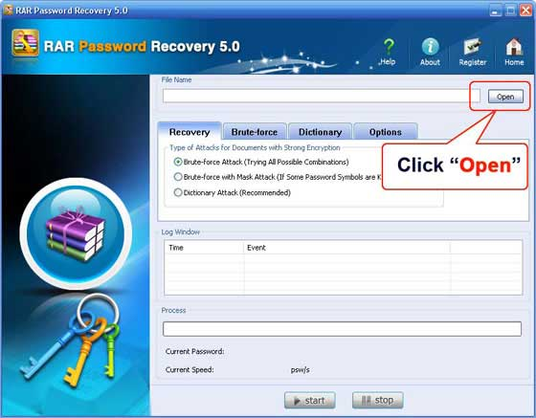
Features:
- Long & complicated passwords can be both recovered
- Supports all versions of RAR
- Very high speed of work
- User-friendly interface to help you operate the program very easily
- Provides 3 kinds of way to recover, namely they are advanced dictionary attack, brute-force attack and advanced brute-force with mask attack
In which cases the program could help you recover the rar password:
- The encrypted rar file is downloaded or received from Internet.
- Received the rar files with passwords protected from others.
- You set a password for your rar file.
Specific ways to crack your rar passwords with RAR Password Recovery in different cases:
- For the rar archives from interntet, usually we can find the password in its readme text or the download page. If you cannot find any useful information, then RAR Password Recovery will offer you “Brute-force Attack” which will try all possible combinations. But be patient, this would take you a bit of time to crack RAR password.
- If you got the rar file your friends or others. If they can be contacted, then just ask them. But how about if they’ve also forgotten, how would you do? There is always the way, don’t worry. Since they may have told you, try to remember any related information about the forgotten password, such as its length including Min and Max length, how many numbers or characters and other symbols, Prefix? Suffix? At this moment, “Brute-force with Mask Attack” can be the way to decrypt the password.
- If you set password for the rar file, then advanced archive password recovery here would be the most successful and fastest because people always have a preference when setting a password or you may still remember some of information. If so, you are suggested to list all the characters you would like to contain in the password, such as your name, nickname, birthday, other emails passwords, your parents names and birthday dates, etc. After that, you can take “Dictionary Attack” on RAR Password Recovery
I’ve just got those details above. For more information, please go into their official website.
Related Article:
http://www.recoverlostpassword.com/article/advanced-rar-password-recovery.html

