Top Solutions to Break Windows XP Password

For those people with little computer knowledge, losing Windows XP password would be panic experiences. They end their wits at breaking Windows XP password, so here I list some options for all users to reset, recover Windows XP administration password, and local user password.

Way 1: Break Windows XP password in Safe Mode with Command Prompt.

Step 1: Press the “F8” before the Windows screen appears. You’d better do it over and over again to not miss the small window of opportunity.

Step 2: You are presented with three variations of Windows Safe Mode you may enter; here you need to highlight “Safe Mode with Command Prompt” by using the arrow key on your key board.
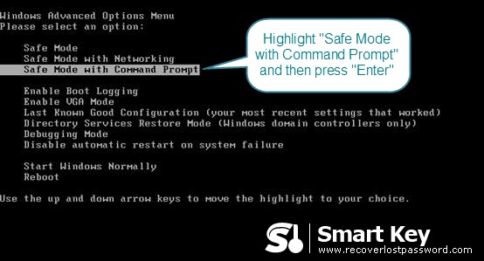
Step 3: Highlight the correct operating system you use and press “enter”.
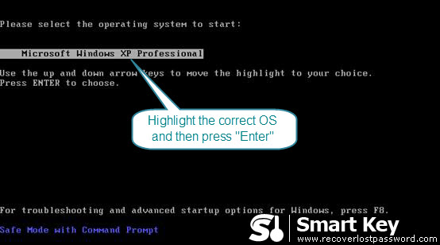
Step 4: Now the command prompt to load up: Input “net user” and press “enter” on your keyboard.

Step 5: This command will list all the user accounts available on this machine. If your user name is jim123, you need to input “net user jim123” and then press “enter” key.

Step 6: This will populate the following command: “Type a password for the user”. Type the new password and press “enter” key.

Step 7: Type your new password again when the command “Retype the password to confirm” appears.

Step 8: Still on the command prompt, type “shutdown -r -t 01” and then press the “Enter” key on your keyboard. This command will restart Windows.
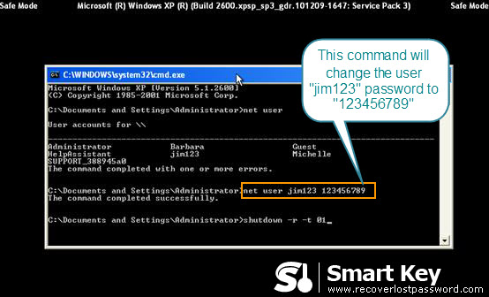
Way 2: Utilize Windows XP Password Breaker Program

Using Windows XP Password Breaker would be your best choice to reset Windows XP password if you have little knowledge about computer and system. It empowers you to recover local account password without a sweat.

Read the bellowing directions to see how easily to break Windows XP password.
Step 1: Here we need another computer to burn password reset disk. Insert a blank CD on this PC, and launch Windows XP Password Breaker.
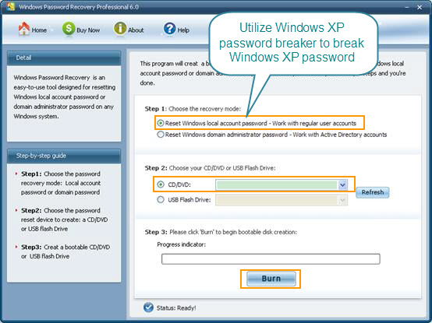
Step 2: Select "reset Windows local account password", and tick “CD/DVD” and choose your target device.

Step 3: Click “burn” to start the Windows XP password reset disk.

Step 4: From CD, boot the computer for which you lost the log-in password. And then choose the system you would like to reset password for.

Step 5: Choose the target user account, and click “Reset”. When two confirmative boxes show, click “Yes” and “OK” respectively. The last step you need to do is to reboot your PC to active the action.

