Useful Tricks for Bypassing Vista Password

System password is a string of characters or words which are used to prevent unauthorized access to PC. Creating Windows password is a good habit to ensure system security. But sometimes unexpected thing happens, you are unable to access to Windows after you neglect the password for a long time or you change password too frequently. In those situations, I am afraid that you need to bypass Vista password with some techniques.

Way One: Using the hint.
If you created a password hint in the past, it may be a simple strategy to enter into Windows with the help of this hint. Type the correct response. If you fail because of bad memory, are you locked out of your computer forever? So try the next method.
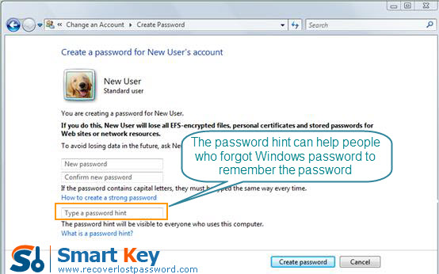
Ways Two: The Third Party Software
Frankly speaking, the third party software would be the best strategy if you are lack of Windows knowledge and don’t want to reinstall Windows. On the market, there are thousands of those kinds of software, but I highly recommend one named Windows Vista Password Recovery in terms of its easy-to-handle and effective functions. It can instantaneously bypass Vista Password without any data loss.
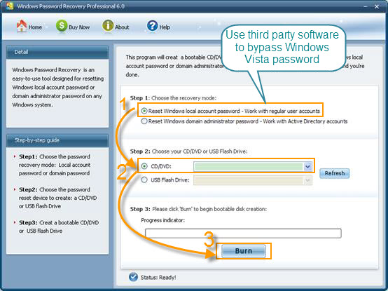
Follow the directions below to see how easily it works to recover Vista password:

Step 1: Download Windows Vista Password Recovery, setup and run it on an accessible computer. Don’t forget to insert a blank CD.

Note: To bypass Vista local account password, choose Windows Vista Password Professional or Standard.
To reset domain administrator password, choose Windows Vista Password Enterprise.

Step 2: On the main interface, there are two recovery modes for your choosing. Here choose “reset Windows local account password”. And tick “CD/DVD”.

Step 3: Start burning a bootable CD by clicking on “Burn”.

Step 4: Insert this CD to the computer you can’t access to and boot it from CD.

Step 5: follow the wizard to select your system and account you’d like to reset password. Click “Reset” and then “Yes”&“OK” in the next popups.

Step 6: The last step you need to do is to restart your computer, and your Windows password has been deleted.

