The Effective Approaches to Bypass Windows XP Password

It is really sickening, powerless feeling to be locked out of your own computer. Sometimes you may forget password after a long vacation. Sometimes the stored password on your hard drive gets corrupted in a system crash. Sometimes, malware changes your password without your knowledge. No matter for what reasons you lost your Windows XP password, the ultimate purpose for us here is to find a way on bypassing Windows XP password.

Here I would like to share my experiences for how to bypass XP password with the effective ways.

Way 1: Reset Windows XP password reset disk
After you install Windows XP system, you are suggested to burn a password reset disk proactively. With the help of it, you are able to reset, recover Windows password if you forget it in the future.

To create a password reset disk, follow the bellowing directions:
- Click “Start”, and then click “Control Panel”.
- In the Window “Control Panel”, click “User Accounts” and choose the account you want to work with.
- Click “Prevent a forgotten password” under “Related Tasks”.
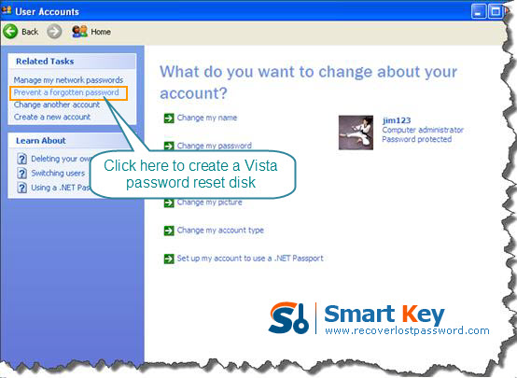
- The “Forgotten Password Wizard” pops up. Click “Next”.
- Insert a blank disk into drive A, and then click “Next”.
- In the “Current user account password” box, type your new password. Click “Next”.
- When the burning progress bar shows 100% complete, click “Next” and then click “Finish”.
- Now you can remove your disk.

Way 2: Have the administrator change your password
If the password you lost is not for administrator account, and there are other user accounts which can access to your PC, one of them may have privilege to log in to your system as the administrator. If so, it becomes much easier to bypass Windows password for you. Just call the administrator to change the password from within his account.
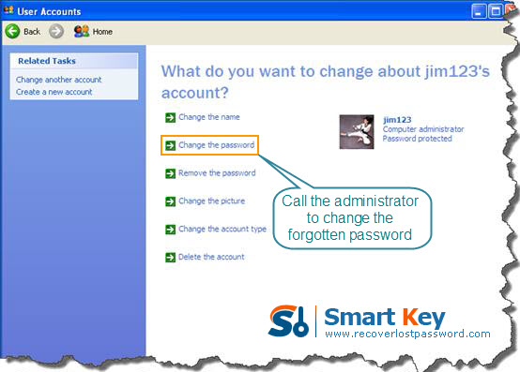
Way 3: Windows XP password Recovery

If administrator account password is lost, obviously the Way 2 is not effective. Don’t worry, there is always a way out. Using the third party to bypass Windows XP password is a good choice. I highly recommend Windows XP password Cracker which is easy enough for computer novices to reset Windows password. To do this, follow the steps below to learn how it works:
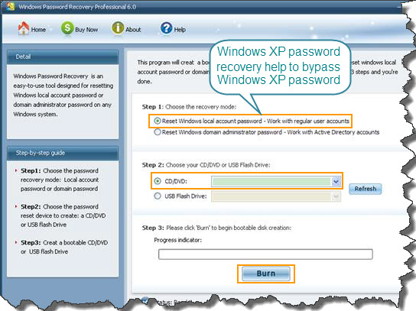
Step 1: Download Windows XP Password Recovery, setup and run it on the accessible computer. Don’t forget to insert a blank CD.

Note: To reset XP local account password, choose Windows XP Password Professional or Standard.

Step 2: On the main interface, there are two recovery modes for your choosing. Choose "reset Windows local account password". And tick “CD/DVD”.

Step 3: Start burning a bootable CD by clicking on “Burn”.

Step 4: Insert this CD to the computer you can’t access to and boot it from CD.

Step 5: follow the wizard to select your system and account you’d like to reset password. Click “Reset” and then “Yes”&“OK” in the next popups.

Step 6: The last step you need to do is to restart your computer, and your Windows XP password has been deleted.

