Must-have Knowledge about Windows Vista Password Cracker

“I’m wondering if there is a place to download the password reset software for vista. My girlfriend forgot her password and can’t get into her laptop. She forgot to make a password recovery disc”

“Hello, every one. My sister went on my computer while I was away and she's not too smart with computers and she changed all my passwords, for the main admin account, and administrator; I was wondering if there is any way I can find out what they are? Or can delete the account without having the reinstall windows. So if someone could please help I would be grateful. Thank you.”

There are so many queries about Windows Vista password Cracker if you browse some Windows forums. And the experienced users often recommend them to have administrator change the password. But please be aware that it is effective on the condition that you need to have administrator user account to access your Vista.

Way 1: Using Vista Password Reset disk
Microsoft Windows Vista allows you create a password reset disk which enables you to Crack Vista Password without any effort. The shortcoming of this option is that you have to create this disk before you lost the password. If you have already forgotten it, we feel sorry that this option is not suitable for you.

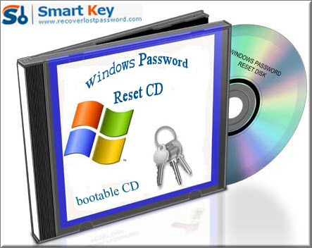

Way 2: Using Vista Password Cracker software
As far as I am concerned, the most practical method to crack Vista password is to use Windows Password Cracker program. No need to reinstall Windows, no requirement about computer knowledge. What is the most important is that it is the emergency solution after you forgot the password without password reset disk at hand. Just with several clicks, you can easily and quickly reset Vista local account password at once.

Follow my directions on how to reset Vista password step by step:

Step 1: Here we need another computer to burn password reset disk. Insert a blank CD on this PC, and launch Windows Vista Password Cracker.

Step 2: Select “reset Windows local account password”, and tick “CD/DVD” and choose your target device.

Step 3: Click “burn” to start the Vista password reset disk.

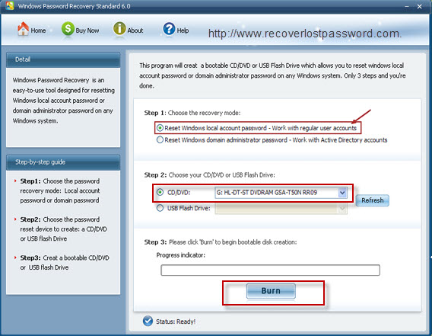

Step 4: From CD, boot the computer for which you lost the log-in password. And then choose the system you would like to reset password.

Step 5: Highlight the certain user account, and hit “reset”. Click “Yes” and “OK” in the next text boxes. The last step you need to do is to reboot your PC to active the action.

