How to use Excel Password Recovery?
Excel Password Recovery has 2 functions. This is the user guide for function 2.
1. 100% Instant Document Decryption (Online Password Remove Service)
2. Recover The Password (Offline and 3 types of attack)

100% Instant Document Decryption
Being urgent to use Excel documents but forget the password? Take it easy, Excel Password Recovery can remove password instantly with the online Excel Password Remover service and get access to the documents without any password. It is available for documents created in MS Office 97-2003.

Follow the tutorial below to learn how to remove Excel spreadsheets password.

Step1: Click "Open" to load Excel spreadsheet.
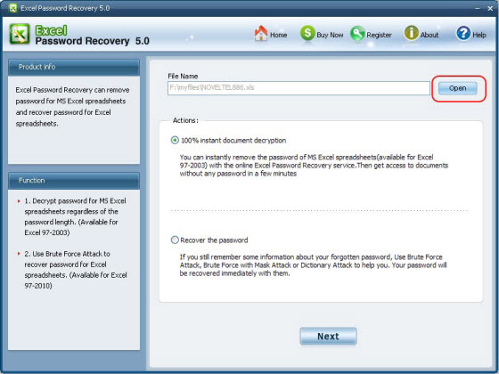
Step2. Select "100% instant document decryption" and click "Next".
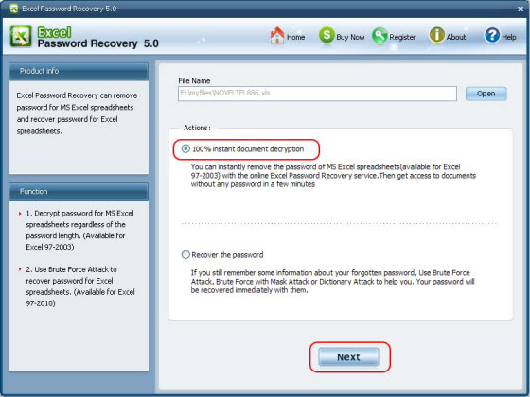
Step3. Click "Decrypt document" to remove password.
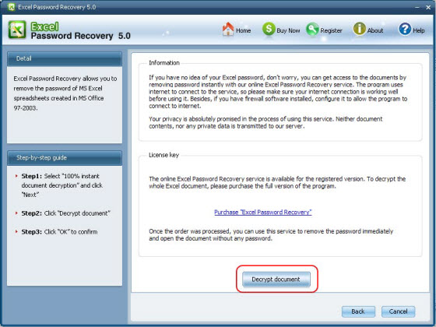
Step4. Remove Excel Password Successfully. The decryped file (*_Fixed.xls) has been automatically saved to the folder where your locked file is.

You can also click "Cancel" to stop decryption or click "Back" to continue other operation.
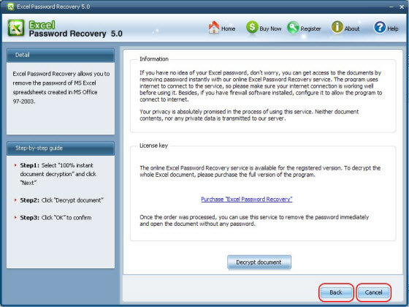
Note: The Excel Password Remover program uses internet to connect to the service, so make sure your internet connection is working well before using it. Besides, if you have firewall software installed, configure it to allow the program to connect to internet.

Recover Excel Password
If you have some information about the forgotten or lost password, you can use Brute-force Attack to recover the password. Excel Password Recovery provides three types of attack: Brute-force Attack, Brute-force with Mask Attack, Dictionary Attack. The program supports recovering password for Excel file created in MS Excel 97-2010.

Follow the tutorial below to learn how to recover password

Step1: Click "Open" to import the target Excel file to the program.
Step2. Select "Recover the password" and click "Next"
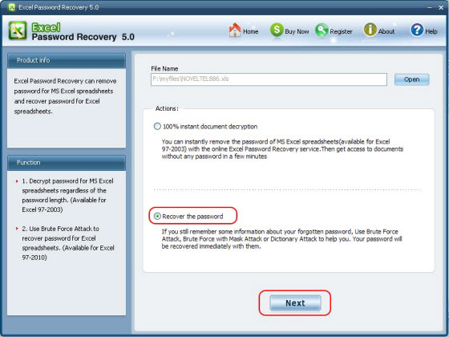
Step3. Select type of attack and click "Start"
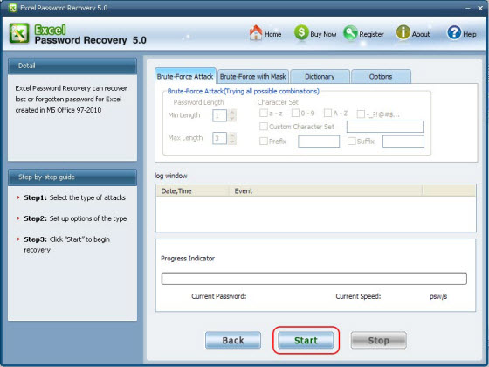
You can click "Stop" to stop operation or click "Back" to continue other operation.
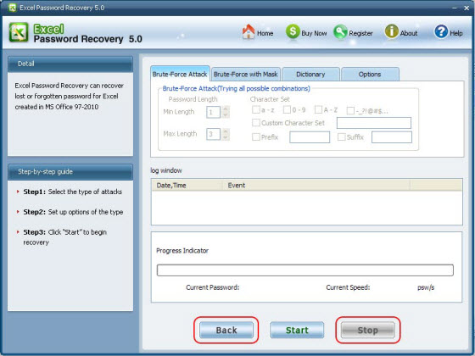
Step4. After clicking "Start" button, the program is recovering the Excel password. Once the password is found, it'll be displayed in the File Opening Password Box. Use the password provided to open the Excel file and view the information.
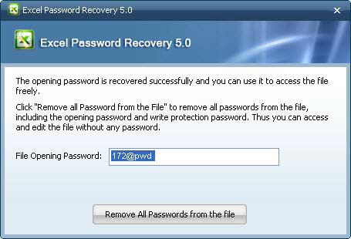

Know more about Excel Password Remover Guide from:
http://www.recoverlostpassword.com/products/excel-password-remover.html

Know more about Excel Password Recovery Guide from:
http://www.recoverlostpassword.com/products/how_to_use_excelpr.html

