The Guide for New Users to Fully Control Firefox Master Password Recovery
Tips: Here is a concise user guide for you to find out the Firefox master password and get back your lost signon information, any inquiries about using the Firefox Master Password Recovery 5.0, please refer to the "Help" document integrated in the program.
Step1: Select the type of attack.
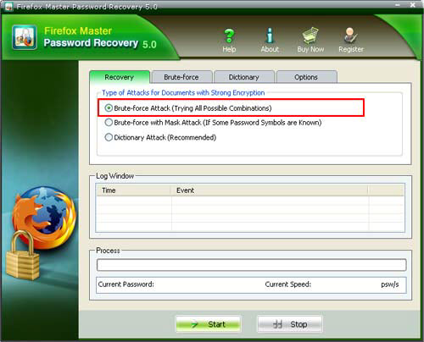
Step2: Click "Start" button in the Menu to initiate the program.
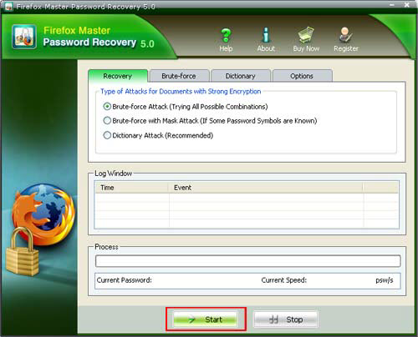
Step3: The program is searching the password. Some time later, a message box pops up to you, displaying the expected password.
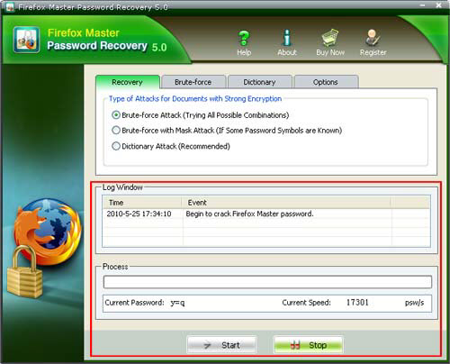
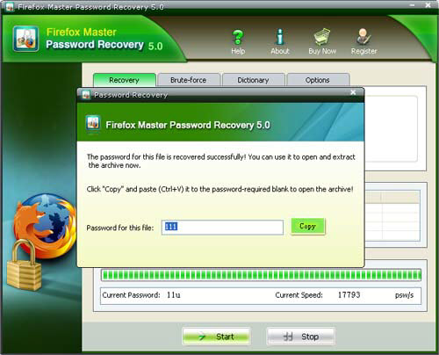

Know more about Firefox Master Password Recovery Guide from:
http://www.recoverlostpassword.com/products/how_to_use_firefoxmasterpr.html

