The Guide to Reset Google Talk Password
Tips: Below are the steps to the login and password information for your Google Talk, Gmail Notifier, Picasa, Google Desktop accounts using Google Talk Password Recovery 5.0. To see the detailed information,please refer to the "Help" document integrated in the program.
Step1: Run Google Talk Password Recovery 5.0.
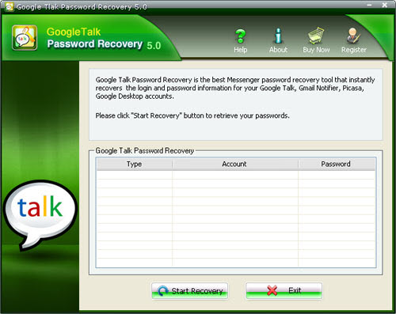
Step2: Click on the "Start Recovery" button.
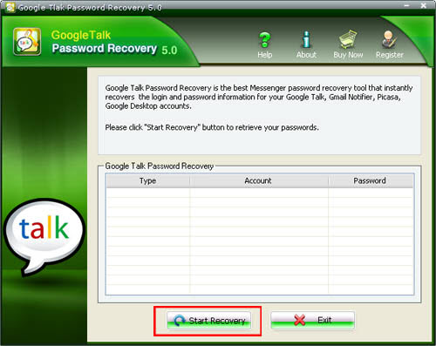
Step3: All the user names and passwords are displayed in the box.
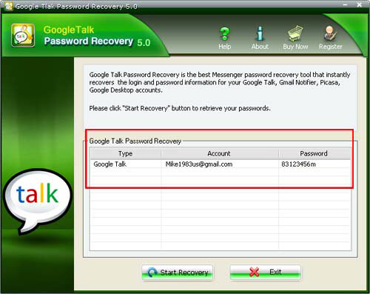

Know more about Google Talk Password Recovery Guide from:
http://www.recoverlostpassword.com/products/how_to_use_googletalkpr.html

