Guides for You to Unlock Excel Password

Nowadays, there are a large quantity of online service and accounts which need corresponding passwords. For easy remembrance and typing, you prefer to have the same password for all your accounts. If so, your security is threatened and it is easier for others to hack into several of your accounts. With this in mind, you had better to create different passwords for the different accounts that you have. Especially for sensitive Excel Workbooks, you need to create different strong passwords to prevent from cracking Excel password. However, you are always getting confused and forgetting your passwords for Excel files. Now, what you need is Excel Password Unlocker which is a professional solution to help you recover lost or forgotten Excel password.

Follow me to see how this easy-to-use tool works:

Firstly, download Excel Password Unlocker, double click setup and install it.
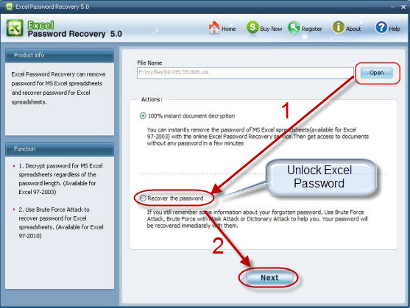
Secondly, import encrypted Excel file to this software by simply clicking “Open” and selecting the file on your PC.

Thirdly, according to your practical condition, choose one attack type that is suitable for you. If you have no idea about anything related to your password, choose “Brute-force attack”; if you can offer some password clues like length, the letter or the letter type it contains, you can choose “Brute-force with Mask attack”; if your password is frequently used and you have a dictionary (txt.) file, you are recommended to select “Dictionary attack”.

Fourthly, set your preference based on the attack type you choose in the previous step.

Fifthly, click on “Start” to start the Excel Password Unlocker.

Sixthly, keep the “password to open” displayed in the popping window in your mind, and then go to Excel program to reset your “password to modify”. Alternatively, click “Remove all password from the file” to erase both passwords at once.

Seventhly, click “OK” to confirm your actions.

Glossary:
Microsoft Excel supports three levels of workbook protection. The user who creates a workbook has read/write permission to a document and controls the protection level. The three levels of document protection are:
File Open Protection: Excel requires the users to enter a password to open a document. This password is called “Password to Open”
File Modify protection. Excel requires the user to enter a password to open the document with write permission. And this password is “Password to Modify”. If the user clicks “Read only” at the prompt, Excel opens the document as read-only.
Read-only recommended protection. If the user clicks “No” at the prompt, Excel opens the document with only read permission, unless the document has other password protection.
Article Source:
http://www.recoverlostpassword.com/article/excel-password-unlocker.html

