Do You Want to Take Easy Way to Hack Your Yahoo Password?

Hack Yahoo password? Some people may misunderstand the meaning of “hack” here. Here we do not mean we can help you hack into others’ yahoo mail accounts with a certain tool. We all know that is illegal. But we have to admit that there are such disgusting people around us. They get other people’s private information with nasty means online intentionally. What we would discuss here is to help you hack your own Yahoo password which has been saved on your IE [Internet Explorer] browser already.

New versions of IE browser can help users save the passwords of websites or Email accounts which they have visited. This does bring us lots of convenience. Since 1999, Internet Explorer has been the most widely used web browser. It is precisely because of this, many people are used to making IE browser remember their passwords instead of taking notes by pen and paper in case of passwords loss.

Internet Explorer can not always be so omnipotent. If you upgrade your IE version, clear your IE cache or a virus attacks your web browser etc., IE may not be able to remember your passwords. Even in some cases, for example, you have to login into one of your business Yahoo email accounts on another computer, but you never spend time remembering its password and answers for its security question, all the information you filled when registering was random. I bet such an awkward trouble could almost get you mad.

But here today I promise you there is way to hack yahoo password and to make it display within your sight. And it’s very easy. Now let’s learn how to hack yahoo password together.

Now I am ready to recommend you a very good yahoo password hacker [Internet Explorer Password Recovery 5.0]. I suppose here you cannot remember your yahoo password or the answers of security questions. Otherwise you do not have the need to hack your password by this tool.
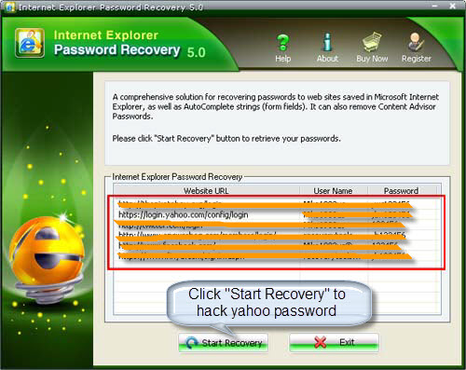
First of all, free download this Internet Explorer Password Recovery 5.0 and the install it properly in your PC.

To begin with, Press “Start Recovery” button and select “Recover IE Password”

Finally, the window will display a list of Website URL, Username and Password. You then can easily find your yahoo username and password there.

Until now, you have successfully got your forgotten yahoo password back by a yahoo password hack. Isn’t very easy? Only a few clicks of buttons can make it. But here I have a small tip. Keep a good habit of recording all your accounts with passwords in a document, in case of sudden memory loss or other accidents.

Article Source:
http://www.recoverlostpassword.com/article/hack-yahoo-password.html

