How to Remove Excel Password after We accidently lost it

Ask:
“A friend of mine had set a password on my valuable Excel document. I was unaware of that and he is not here right now with me. He left for vacations with his family. So I am unable to contact him anyway. I need that file. So is there any possibility for me to remove Excel password or change it?”

“I have got a file that is an excel spreadsheet. But I have some-how lost my password for it and need to remove it. I was working on it for a school you see. Any help asap be great.”

Answer:
We are frequently being asked such kinds of question as above. Frankly speaking, Microsoft Office doesn’t offer built-in features to remove Excel password after the users lost it. That’s why so many people are at a loss for retrieving their password. Now there is an easy-to-use Excel Password Remover that can help you indeed. It is a professional utility to remove lost or forgotten Excel password without any data loss. No matter how long and complex your password is, you can easily remove it and instantly access to your Excel workbook.

Below is the detailed guide on how to remove Excel password.
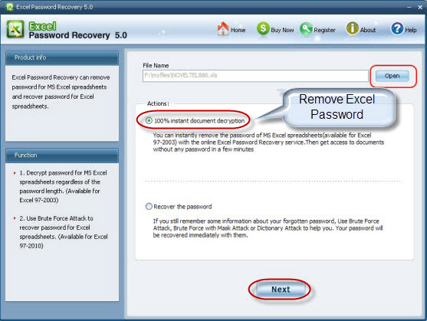
- Download Excel Password Remover, setup and run it.
- Click “Open” and select your encrypted Excel file to load it into this program.
- Choose the appropriate attack type according to your condition.
- Set parameter of your password such as "prefix," "suffix," "contains" or "length” and it can greatly expedite the recovery process.
- Click on “Start” to initiate the recovery. After a while, you will be noticed with “the password to open”.
- It is optional for you to remember this password and go to Word program to reset a new one or select to “remove all passwords from the file”.

Below are tips to create new password:

- Select a password that is easy to remember and difficult for others to guess.
- Do not share the password with others.
- Excel passwords are case-sensitive.
- If you lost your password again, try Excel Password Remover.

Article Source:
http://www.recoverlostpassword.com/article/excel-password-remover.html

