Help! I Lost Windows Vista Password

Question: I have lost Windows Vista Password, How should I do?

Answer: Don’t worry! This kind of situation happens to many people every day. It is not coming to the end of your world. Actually, there are several ways to retrieve your lost Vista password.

Way 1: Take educated guesses
People often seek complicated technology ways to do things. However, in fact it often works with traditional ones. You should put some serious guessing effort before you try more complicated ways to retrieve your password.

Normally, the password is often inspired by the things, place, people related to your life no matter how complicated it is. So jog your memory and remember it.

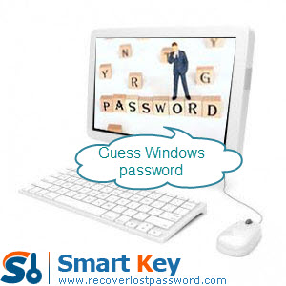

Way 2: Have an administrator change your password
You can change your password with the administrator on the condition that the password you lost is not the administrator account. Otherwise, this option is not your best choice.

Way 3: Use Vista reset disk
If you created a Vista reset disk at some point in the past, now it is the time to utilize it to reset your Windows Vista password.

Note: This password reset disk still works no matter how many times you reset Vista password after you burned it.

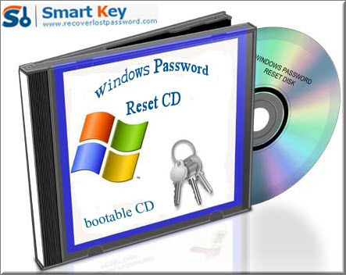

Way 4: Windows Password Recovery Software
If you can’t remember your forgotten Vista password, and no password reset in handy, and you’re the only user on your PC, then it’s time to get serious.

When meeting the worst condition, there is still a solution for you. That is Windows Vista Password Recovery which can easily reset lost Vista password without any additional requirements.

Learn the steps below to get you out of the problem:

Step 1: Insert a blank CD or USB flash driver on a computer which can log in to Windows. Launch Vista Password Cracker after you download and install it.

Step 2: Choose “reset Windows local account password”, and choose your target device from the drop-down menu.

Step 3: Click “Burn” to create bootable CD.

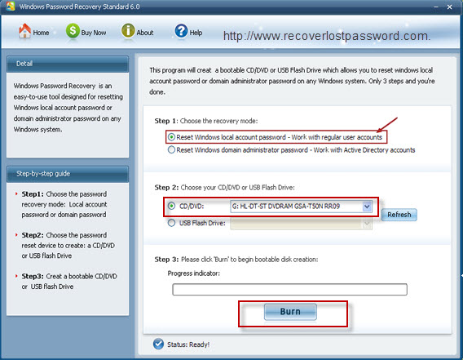

Step 4: Insert this CD to the computer you would like to change password for, and boot it form CD.

Step 5: Choose the system you want to reset password. Normally, one computer installs one system.

Step 6: For local account password reset, highlight certain password and click “reset”, and then click “Yes” and “OK” when two indicators appear. The password has been removed.

Step 7: Reboot the computer to finish the reset.

I am sure you can successfully find your lost Vista password with certain one way recommended above.

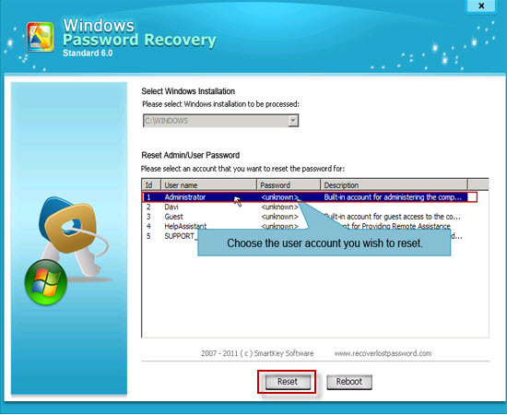

Article Source:
http://www.recoverlostpassword.com/article/lost-vista-password.html

