How to Control Miranda Password with the Easiest Solution
Tips: Below are the steps to recover and decrypt lost or forgotten Miranda passwords with a click using Miranda Password Recovery 5.0, To see the detailed information, please refer to the "Help" document integrated in the program.
Step1: Run Miranda Password Recovery.
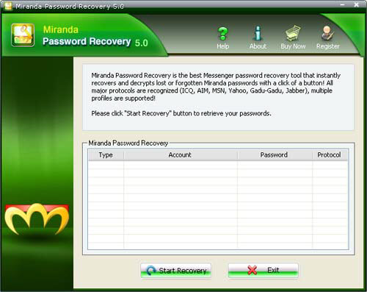
Step2: Click on the "Start Recovery" button.
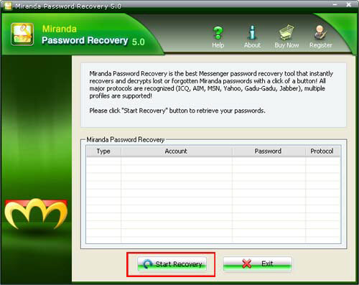
Step3: All the emails with Server Address, Login, Passwords, and Server Type are displayed in the box.
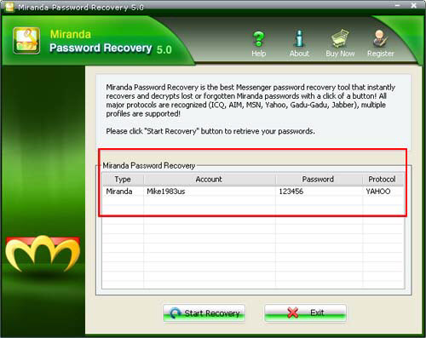

Know more about Miranda Password Recovery Guide from:
http://www.recoverlostpassword.com/products/how_to_use_mirandapr.html

