The Guide for Using MSN Password Recovery
Tips: Below are the steps to recover forgotten or lost passwords for MSN Messenger, Windows Live Messenger and Windows Messenger accounts using MSN Password Recovery 5.0, To see the detailed information, please refer to the "Help" document integrated in the program.
Step1: Run MSN Password Recovery.
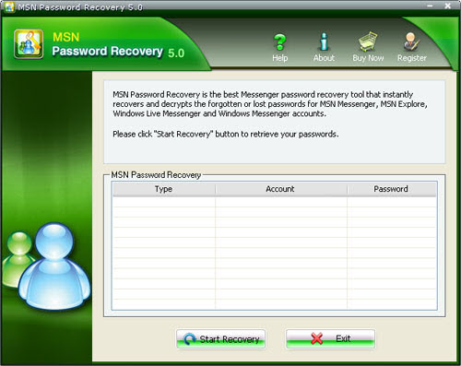
Step2: Click on the "Start Recovery" button.
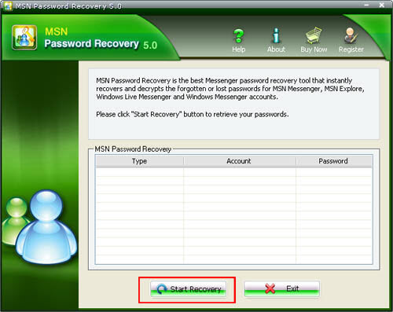
Step3: All the user name and password are displayed in the box.
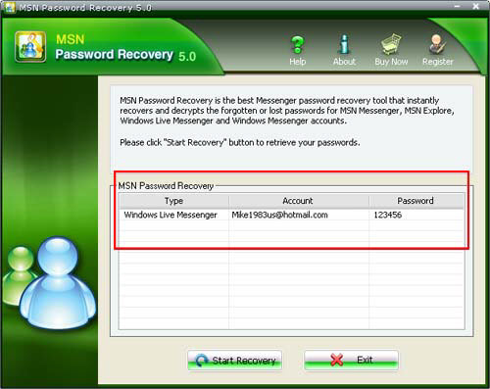

Know more about MSN Password Recovery Guide from:
http://www.recoverlostpassword.com/products/how_to_use_msnpr.html

