Adding and Cracking MS Office Password can’t be too difficult
It is smart for you to assign password protection to some of your Office documents that contain personal data if you share a computer with someone else or you empower others to gain access to your computer in a multi-user environment. In fact, different versions of Microsoft Office have different steps for creating password, so a lot of Office users feel confused to do it for each version. Therefore, we would share how to assign password protection in detail. What’s more, to help those with bad memory, we also provide the easy guide on how to crack Office password if you accidently forgot or lost it. After reading this article, you will never worry about confidential problems and password loss.

Section I: How to password protect Office files
Add a password to Office 2003:
- Click “Start”->“All Programs”->“Microsoft Office”.
- Choose the program you desire.
- Open the document for which you want to add a password by clicking “File”->“Open File” on the menu bar.
- Click “Tools”->“Options”-“Security”.
- Select the level of protection you want. If you want to prevent file opening, type a password into the “Password to open” option. If you want to prevent modification to the document, enter a password into “Password to modify” area.
- Re-enter the password into the appropriate box for the option that you chose and then click “OK”.

Add a password to Office 2007:
1. Follow the same steps as Step 1, Step 2 for Office 2003.
2. Click “Office Button”->“Open” to open the document you need to set a password for.
3. Click “Office Button”->“Save as”.
4. A “Save as” window pops up, and then click “Tools”->“General Options”.
5. The following steps are the same as Step 5, Step 6 for Office 2003.
6. Click “Save” to save your settings.

Add a password to Office 2010:
- The previous steps are the same as Step 1, Step 2 for Office 2003.
- Click “File”-“Open” to open your document you would like to assign a password.
- Hit “File”->“Info”-“Protect Document”-“Encrypt with Password”.
- Type your password twice in the next popups.
- Click “Save” to save your settings.

Section II: How to Crack Office password

- Download Office Password Cracker, install and launch it.
- Import the file to this program by clicking “open” and selecting the file on your PC.
- There are two recovery modes for you choosing, you can choose one based on your practical conditions. You are suggested to choose “100% instant document decryption”.

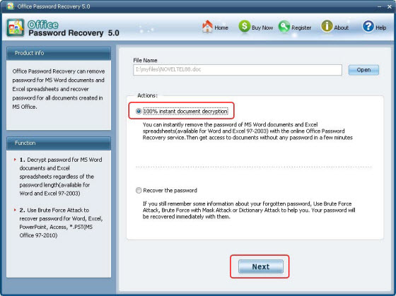

- Click “Next”->”Decrypt Document” by following the wizard.
- After it finished, a fixed file will appear in the folder where your locked file locates.

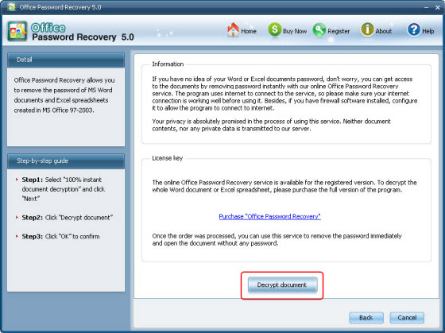

Tips: 1. This utility supports Office 2000, 2003, and 2010.
2. Create a password which is easy-to-remember for you but hard-to-guess for others.
3. Never save a copy of your password on your PC where a hacker can access to. Just remember in your mind, if accidently forgot it, fell free to try Office Password Recovery Tool.

Article Source:
http://www.recoverlostpassword.com/article/office-password-craker.html

