How to use Office Password Recovery?
Office Password Recovery has 2 functions. This is the user guide for function 2.
1. 100% Instant Document Decryption (Online Password Remove Service)
2. Recover The Password (Offline and 3 types of attack)

100% Instant Document Decryption
Being urgent to use Word or Excel documents but forget the password? Take it easy, Office Password Recovery can remove password instantly with the online Office Password Remover service and get access to the documents without any password. It is available for documents created in MS Office 97-2003.

Follow the tutorial below to learn how to remove Word documents and Excel spreadsheets password.

Step1: Click "Open" to load Word document or Excel spreadsheet.
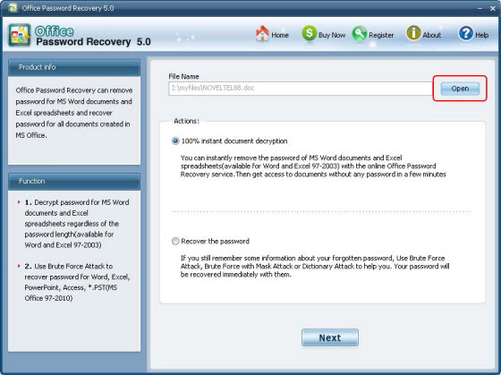
Step2: Select "100% instant document decryption" and click "Next".
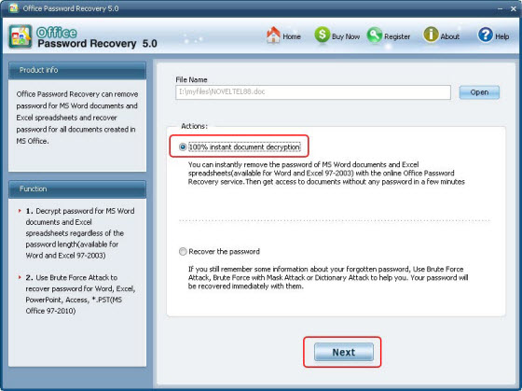
Step3: Click "Decrypt document" to remove password.
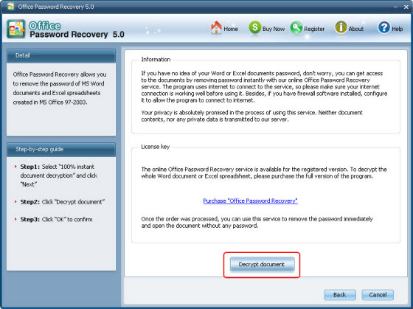
Step4. Remove Office Password Successfully. The decryped file (*_Fixed.doc or *_Fixed.xls) has been automatically saved to the folder where your locked file is.
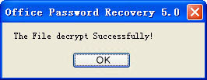
You can also click "Cancel" to stop decryption or click "Back" to continue other operation.
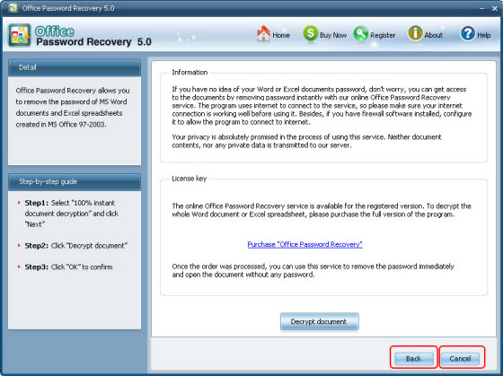
Note: The Office Password Remover program uses internet to connect to the service, so make sure your internet connection is working well before using it. Besides, if you have firewall software installed, configure it to allow the program to connect to internet.

Recover Office Password
If you have some information about the forgotten or lost password, you can use Brute-force Attack to recover the password. Office Password Recovery provides three types of attack: Brute-force Attack, Brute-force with Mask Attack, Dictionary Attack. The program supports recovering password for Word, Excel, Access, PowerPoint and *.PST file created in MS Office 97-2010.
Step1: Click "Open" to load password protected document.
Step2. Select "Recover the password" and click "Next"
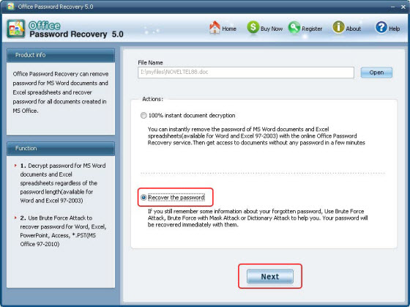
Step3. Select type of attack and click "Start"
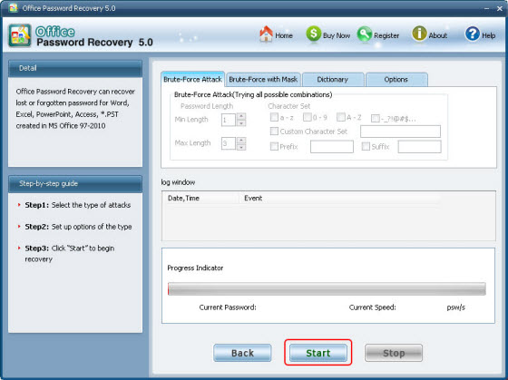
You can click "Stop" to stop operation or click "Back" to continue other operation.
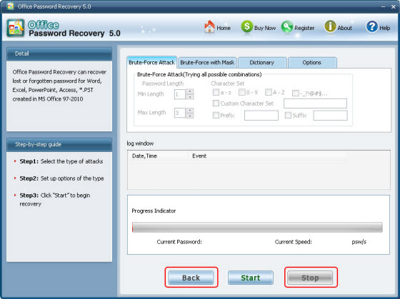
Step4. After clicking "Start" button, the program is recovering the office file password. Once the password is found, it'll be displayed in the File Opening Password Box. Use the password provided to open the office file and view the information.
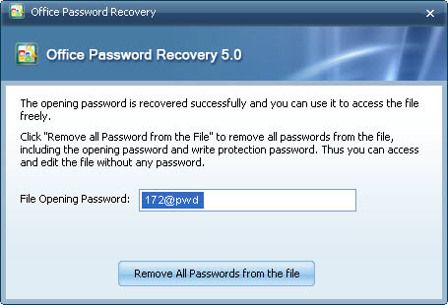

Know more about Office Password Remover Guide from:
http://www.recoverlostpassword.com/products/office-password-remover.html

Know more about Office Password Recovery Guide from:
http://www.recoverlostpassword.com/products/how_to_use_officepr.html

