How to Create and Recover MS Office Password
When you are working on a Microsoft Office document that contains personal data or confidential data, you prefer to create a password to protect it. Although the password is not as strong as encryption, but it is secure enough to keep out casual snoops. Of course, it is important to create a password-protect Office document, and the chances are you lost or forgot the password which is too long and complex to remember. How would you like to recover Office password?

Don’t worry, in this article we provide you the easy guide on how to create MS Office password and how to recover Office password if you accidently lost it.

Part I: How to Create Office Password
It contains different applications depending on the version of Microsoft Office you are using. But typically the base offering includes Microsoft Word, Excel, PowerPoint and Outlook. Read this article to learn how to create Office password for each Office applications.

Part II: How to Recover Office Password
Office Password Recovery is such a useful utility to help you retrieve lost or forgotten Office password. With it, you can easily crack not only Office “password to open” but also Office “password to modify”. What’ more amazing is that it works well with all Office program and all versions of each. Follow the easy steps:

Step 1: Download Office Password Recovery, setup and run this program by following the wizard.

Step 2: Click “Open” to import the Office file on your computer to this program. It supports Word/Excel 2003, Word/Excel 2007, and Word/Excel 2010.

Step 3: Choose the recovery mode according to your special requirements.
If you can work online, you are suggested to choose “100% instant document decryption” which is fast, efficient enough.
If you want to recover Office newer versions of MS Office, choose “recover the password”.

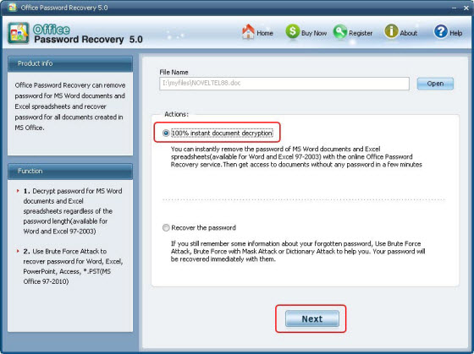

Step 4: Click “Next” and then click “Decrypt Document”.

Step 5: This program will generate another unlocked Office file after it finished recovery.

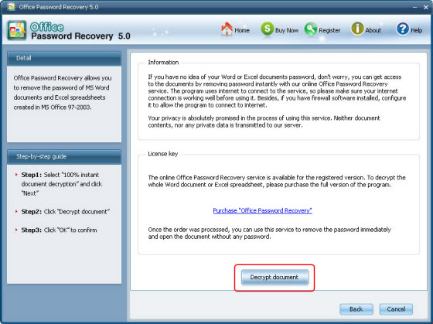

Congratulations, you have successfully recover Office password.

Article Source:
http://www.recoverlostpassword.com/advanced-office-password-recovery.html

