The Guide to Recover Opera Master Password in Less than a Minute
Tips: Below are the steps to remove the master password in the Opera web browser by using Opera Master Password Recovery 5.0. To see the detailed information, please refer to the "Help" document integrated in the program.
Step1: Run Opera Master Password Recovery.
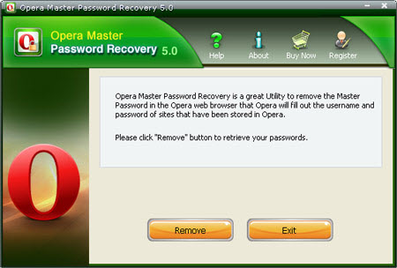
Step2: Click on the "Remove" button.
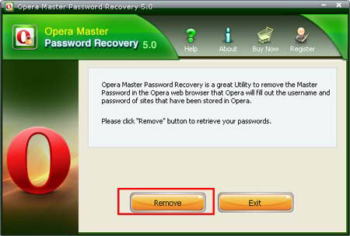
Step3: The Master Password in the Opera web browser will be removed immediately!
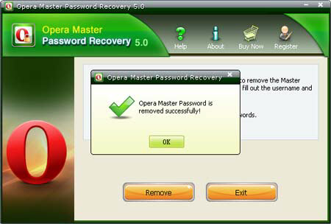

Know more about Opera Master Password Recovery Guide from:
http://www.recoverlostpassword.com/products/how_to_use_operamasterpr.html

