The Guide for New Users to Fully Control Outlook Express Password Recovery

Tips: Below are the steps to recover server name, login and password for all mail and newsgroup accounts saved in Outlook Express, as well as passwords to "identities" by using Outlook Express Password Recovery 5.0. To see the detailed information,
Please refer to the "Help" document integrated in the program.
Part 1: Recover Email Password
Part 2: Recover Identities password

How to Recover Email Password

Step1: Start the program, then an interface will pop up. Select the "mail password" tab.
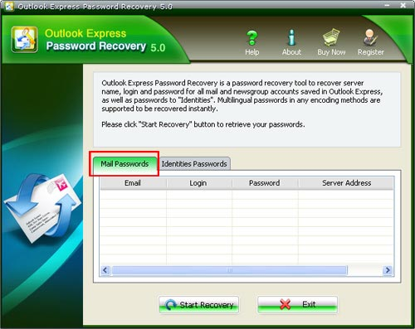
Step2: Click the "Start Recovery" button, all mail accounts and their related passwords will be shown in the column.
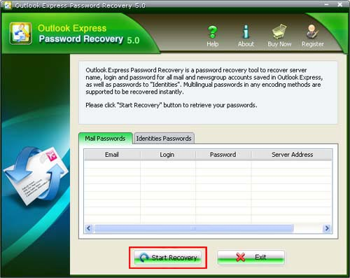
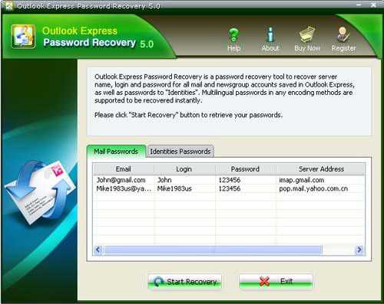

How to recover Identities password

Step1:Start the program, then an interface will pop up. Select the "identities password" tab.
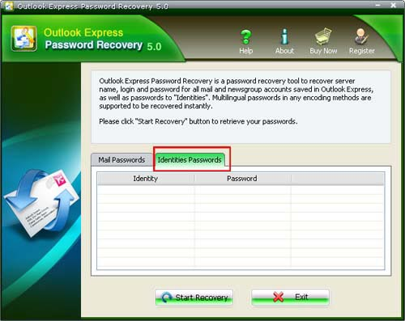
Step2 : Click the "Start Recovery" button, all the identity of the outlook express users and passwords will be shown in the column.
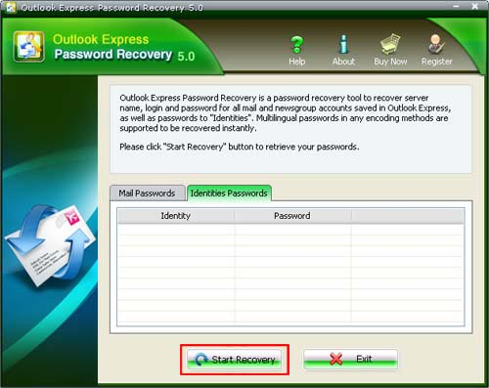
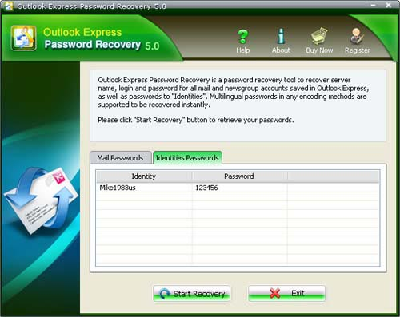

Know more about Outlook Express Password Recovery Guide from:
http://www.recoverlostpassword.com/products/how_to_use_outlookexpresspr.html

