The step-by-step User Guide for Outlook Password Recovery
Tips: Below are the steps to recover lost or forgotten passwords for protected Personal Storage Files (*.pst), as well as passwords to mail accounts, Windows Mail using Outlook Password Recovery 5.0. To see the detailed information, please refer to the "Help" document integrated in the program.
How To Recover PST File Password
How To Recover Email Account Password

How to Recover PST password

Step1: Selected the "PST File Password " tab.
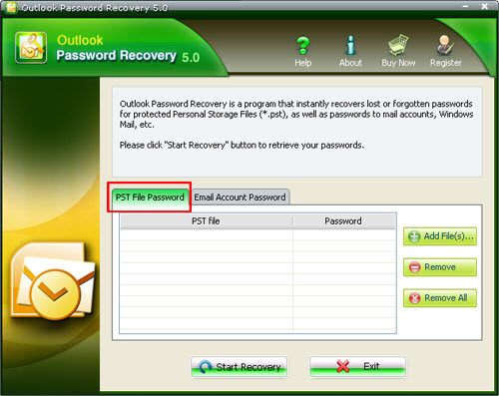
Step2: Select the file you want to recover the password(s) for. Click the "Add file" button to select the necessary file from the dialog box, and click the "open" button to confirm the process. And the location of the PST file will be shown in the status bar.
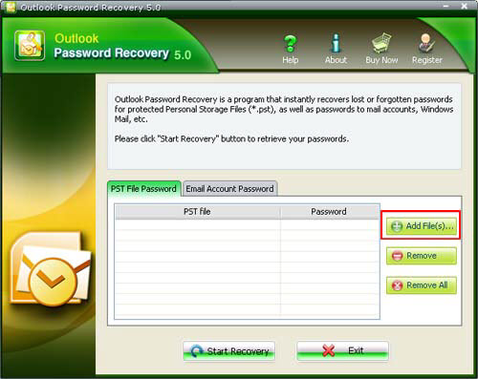
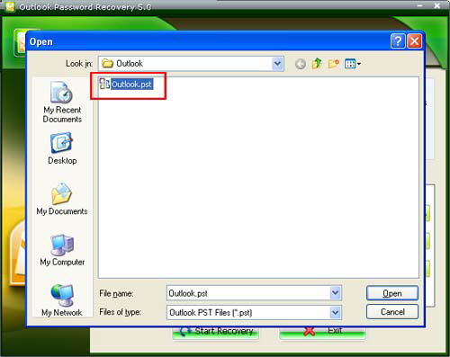
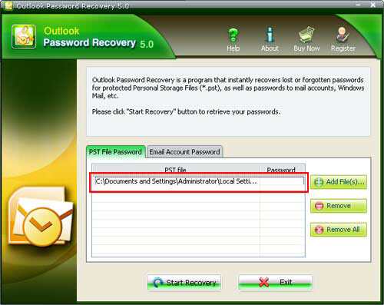
Step3: Click "Star Recovery" button, the password to this given file will be displayed immediately under the "password" tab in the status bar.
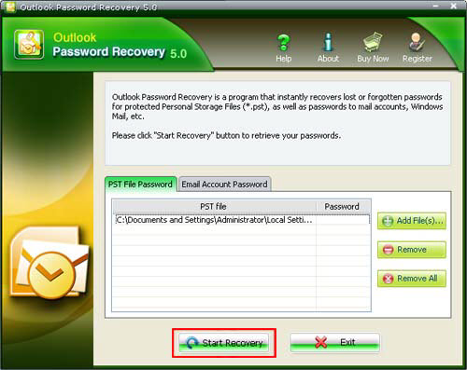
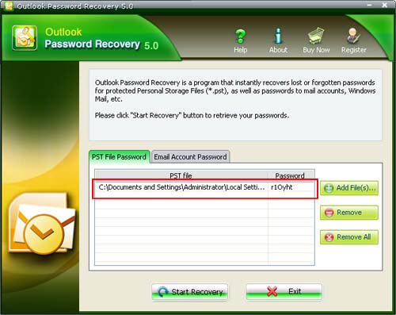
Note: In some cases, the password recovered by Outlook Password Recovery is not the same as the one which has been originally set. That's due to encryption algorithm used in Outlook – the original password is not stored in the file. But that password which is shown by Outlook Password Recovery will be accepted by Outlook without problems – just try. And of course, after logging into Outlook, you'll be able to change that password to any one, or just remove it.

How to Recover Email account password

Step1: Selected the "Email Account Password "tab. Differed from "the PST file password "tab. Under this tab, there are five subdirectories in the status bar to show the detail information of the E-mail Account.
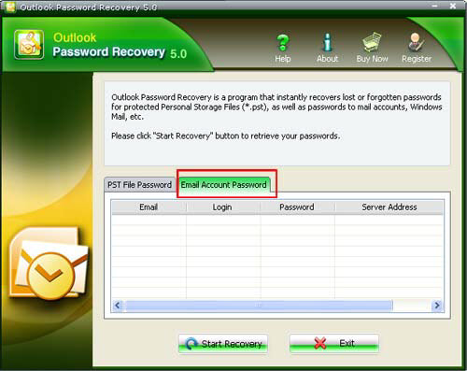
Step2 : Click the "Start Recovery" button. All the emails with login, password, Server Address, and protocol are displayed in the column.
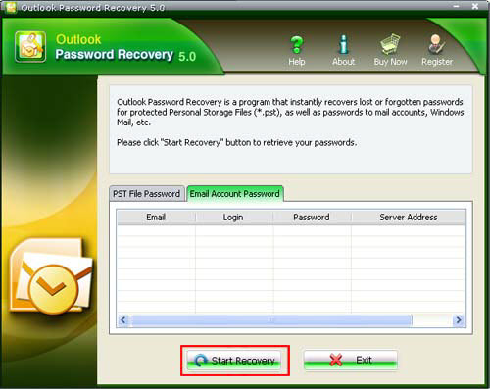
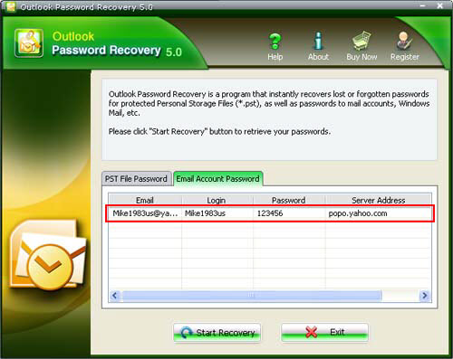

Know more about Outlook Password Recovery Guide from:
http://www.recoverlostpassword.com/products/how_to_use_outlookpr.html

