How to Reset PDF Password with PDF Password Recovery 5.0
Tips: We provide a tutorial about how to find the password with PDF Password Recovery 5.0, please click "Help" button on the program interface for details.
Step 1: Click "Open" button to browse the full path of the PDF file on your PC.
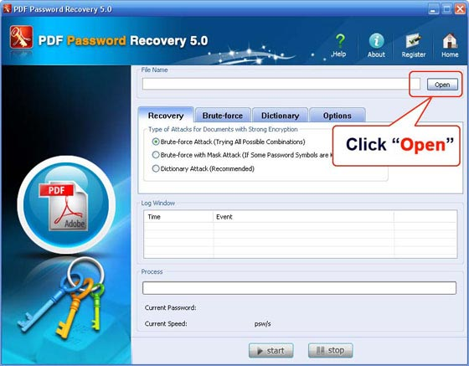
Select your file in the Open File window and click "Open".
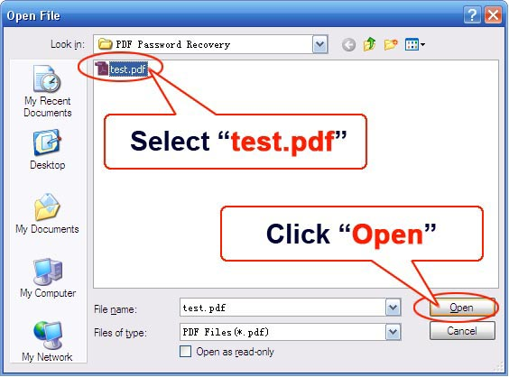
Step 2: On the "Recovery" tab, select "Brute-force Attack (Trying All Possible Combinations)".
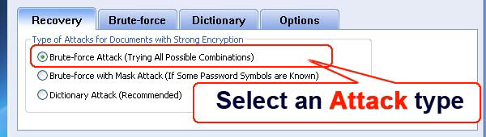
Step 3: Click "Start" button in the Menu to initiate the program.
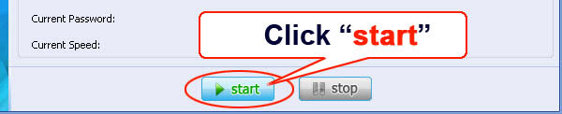
Step 4: Some time later, a message box pops up to you, showing the User Password expected. Click "Remove All Passwords from the File" to remove all the restrictions placed on the PDF file. Click "OK".
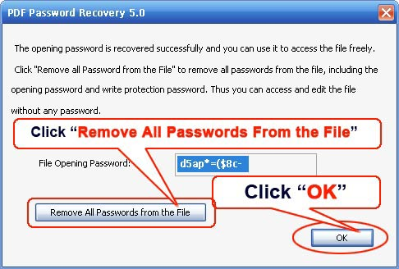

Know more about PDF Password Recovery Guide from:
http://www.recoverlostpassword.com/products/how_to_use_pdfpr.html

