The Guide to Reset PowerPoint (PPT) Password
Tips: Here is a concise user guide for you to quickly get familiar with PowerPoint Password Recovery 5.0. Any inquiries about using the program please refer to the "Help" document integrated in the program.
Step 1: Click "Open" to import the target PowerPoint file to the program.
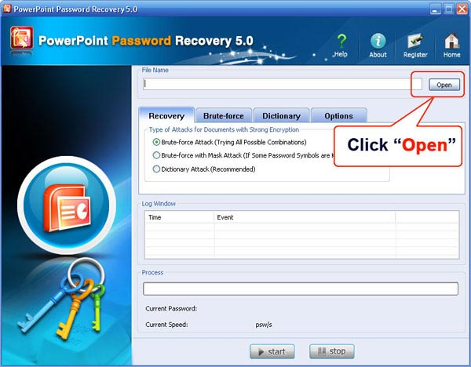
Select your file in the Open File window and click "Open".
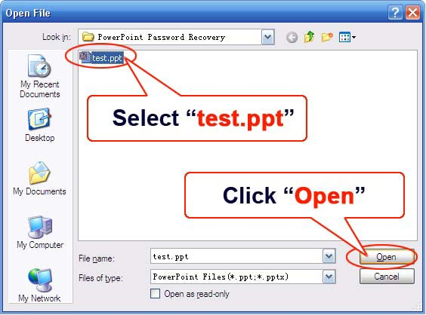
Step 2: On the "Recovery" tab, select "Brute-force Attack (Trying All Possible Combinations)".
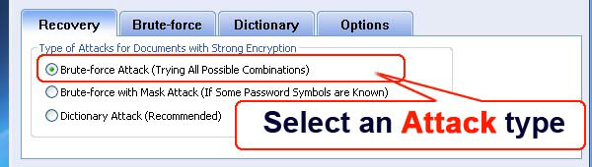
Step 3: Click "Start" button in the Menu to initiate the program.

Step 4: Some time later, a message box pops up to you, showing the User Password expected. Click "Remove All Passwords from the File" to remove all the restrictions placed on the PPT file. Click "OK".
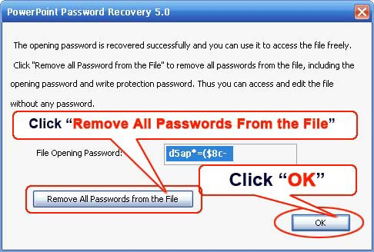

Know more about PowerPoint Password Recovery Guide from:
http://www.recoverlostpassword.com/products/how_to_use_powerpointpr.html

