The Guide on how to Recover Passwords for WinRAR/RAR Archives Easily
Tips: This guide is to introduce you the easiest way to use RAR Password Recovery 5.0. Detailed information is available on the "Help" file integrated in the program, please refer to it if any inquiries.
Step 1: Click "Open" button in the Menu or the "Open" button to browse the full path of the WinRAR/RAR.
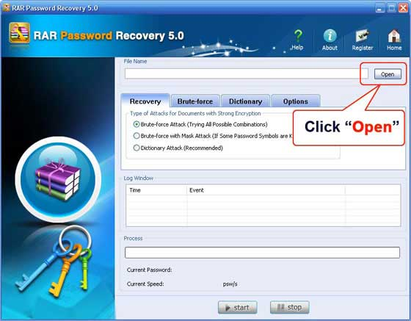
Select your WinRAR/RAR file in the Open File window, and click "Open".
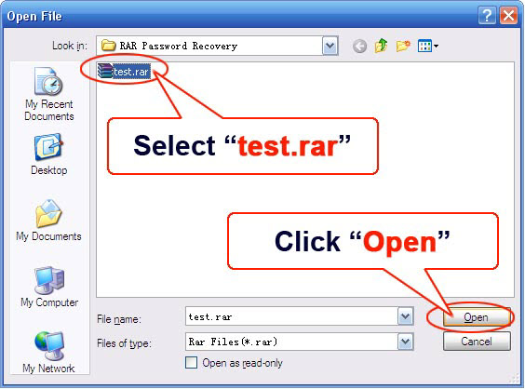
Step 2: On the "Recovery" tab, select "Brute-force Attack (Trying All Possible Combinations)".
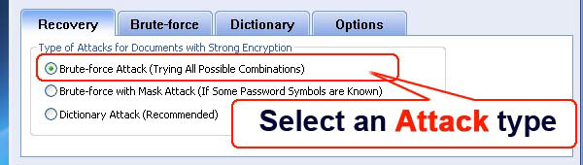
Step 3: Click "Start" button in the Menu to initiate the program.
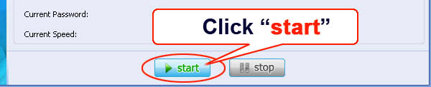
Step 4: The program is processing for the password. Some time later, a message box pops up to you, displaying the expected password. Click "OK".
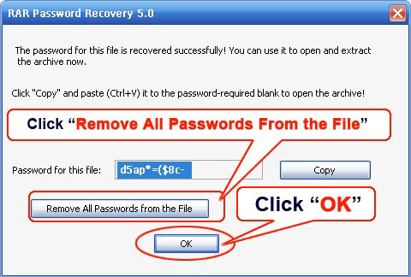

Know more about RAR Password Recovery Guide from:
http://www.recoverlostpassword.com/products/how_to_use_rarpr.html

