Full Solutions to Recover Windows XP Password
Do you think that you absolutely have to reinstall your operating system after having lost your Windows password? Let me tell you the truth: You are absolutely wrong. There are couples of solutions that let you recover Windows XP password even administrator password. In this article, I list some methods on how to recover XP password, hope it can help you.

Method I: Recover Windows XP password in Safe Mode

Starting your computer in Windows XP Safe Mode can help you access to Windows XP if you forgot Windows XP password.
- Restart your PC, and press the “F8” key before the Windows XP splash screen appears. The time is very short, you need to press it as quickly as possible and never miss. Otherwise, Windows XP is probably continuing to boot normally. And you have to restart your computer and press “F8” again.
- You will enter “Advanced Boot Options”. Using the arrow key on your keyboard to highlight “Safe Mode” Option and press “Enter”.
- The account logon screen appears, and you must log on with the administrator password. The default administrator password is blank unless you reset it.
- Now your PC is in Safe Mode.

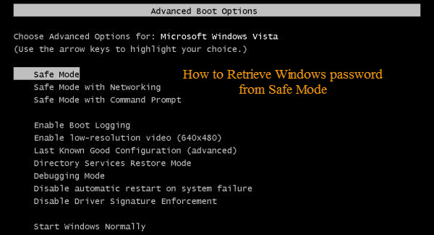

Now that you enter into Windows XP Safe Mode, recover Windows XP password is just a piece of cake.
- Click on “Start”->”Control Panel”->”User Accounts and Family Safety”->”User Accounts”->”Change your password”.
- Respectively enter your new password in the first and second text boxes.
- It is optional to set a password hint. It is used to jog your memory if you enter the wrong password in the future.
- Confirm your changes by clicking on “change password”.

Method II: Use Windows XP password Recovery

Windows XP Password Recovery must be the easiest solution for the users with basic computer knowledge. It is easy enough with user-friendly interface to recover lost or forgotten Windows XP password. It recovers not only local user account password but also local administrator password.

To start the recovery, please the following the directions below carefully:
Step 1: Burn bootable CD.
We need another computer which can log into Windows to burn this CD. So insert a blank CD on this computer, and then launch Windows XP Password Recovery.
Choose "reset Windows local account password" and device (here we tick “CD/DVD”).
Click “burn” to start the bootable CD burning.

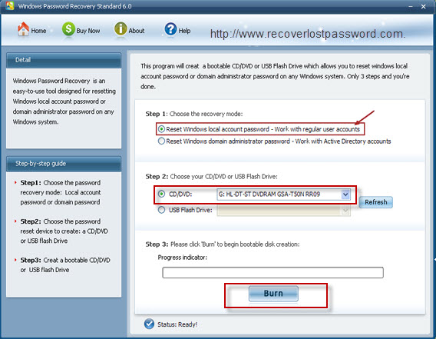

Step 2: Reset Password
Insert this CD on the computer you can’t access to and boot it from CD.
You will enter the main interface of this program. Select the Windows installation and the user account you would like to reset password.
Follow the wizard to remove XP password.
Restart your PC to finish the reset.

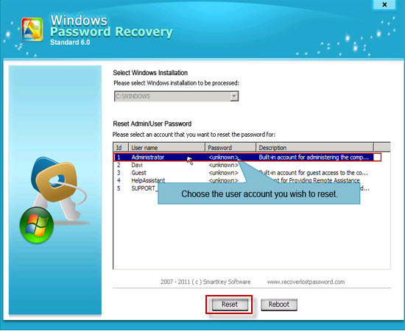

Recover XP password is quite simple and easy. If you are advanced users, choose Method 1; if you really enjoy easy solution, Method 2 is your best choice.

Article Source:
http://www.recoverlostpassword.com/article/recover-xp-password.html

