How to Use Trillian Password Recovery
Tips: Below are the steps to recover lost or forgotten Trillian passwords by using Trillian Password Recovery 5.0. To see the detailed information, please refer to the "Help" document integrated in the program.
Step1: Run Trillian Password Recovery.
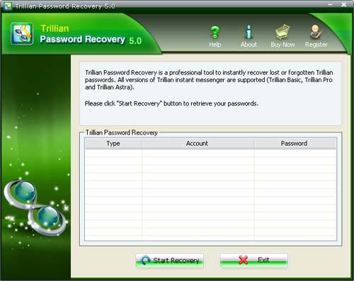
Step2: Click on the "Start Recovery" button.
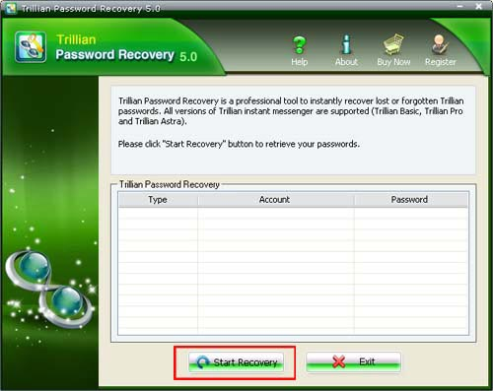
Step3: All the emails with Server Address, Login, Passwords, and Server Type are displayed in the box.
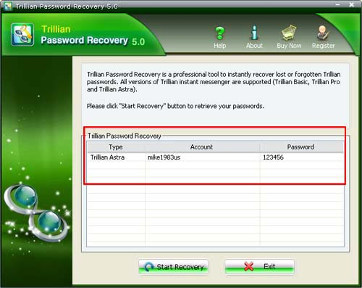

Know more about Asterisk Password Recovery Guide from:
http://www.recoverlostpassword.com/products/how_to_use_trillianpr.html

