How to use Windows Password Recovery Enterprise?
Windows Password Recovery Enterprise 6.0 is an easy-to-use tool designed for resetting local administrator or domain administrator passwords on any Windows system. You only need to burn a bootable CD/DVD/USB and boot from CD/DVD/USB to reset your lost password. The following will show you a step-by-step guide to complete windows password reset tasks.

Step 1. Download and Install
1. Download a free demo version of Windows Password Recovery Enterprise 6.0 (The free demo version lists all the
user names, but doesn't reset the passwords.) .
2. Double-click on the file to install Windows Password Recovery Enterprise 6.0. You can install it on any PC you have access to, not necessarily on a computer you wish to unlock.
3. The installation process is quick. Upon successful completion of the installation, an installation successful screen will be displayed! Enable the "Run Windows Password Recovery Enterprise 6.0. " check-box and click the "Finish" button. Windows Password Recovery Enterprise 6.0 will be launched automatically.

Step 2. Brun Windows Password Recovery Enterprise to CD/DVD/USB Flash Drive:
1. Choose the password recovery mode.
Select "Reset Windows domain password".
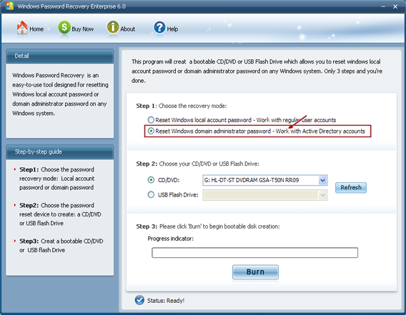
2. Choose what windows password reset device to burn :
Insert a CD/DVD disk into the CD-ROM drive or USB Flash Drive into a USB port on the computer and specify the CD or USB
burning drive from the pull-down list of the CD/DVD or USB flash options.
Select "CD/DVD" if you want to burn windows password recovery Enterprise 6.0 to CD/DVD disk to reset your windows password.
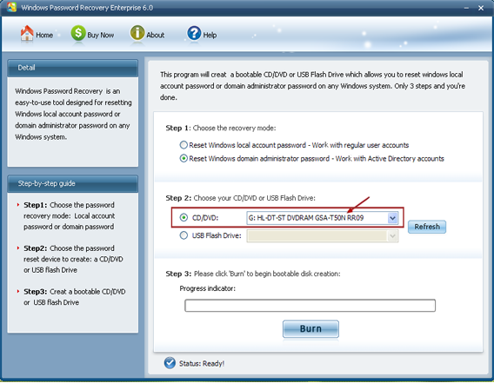
Select "USB flash Drive" if you want to burn windows password recovery Enterprise 6.0 to USB flash drive to reset your windows password.
3. Click "Burn" button :
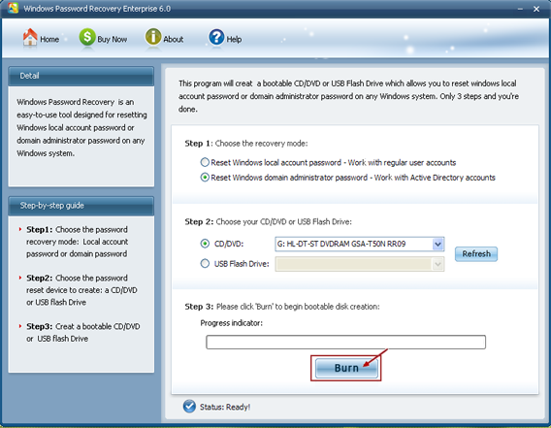
4. The burning process starts :
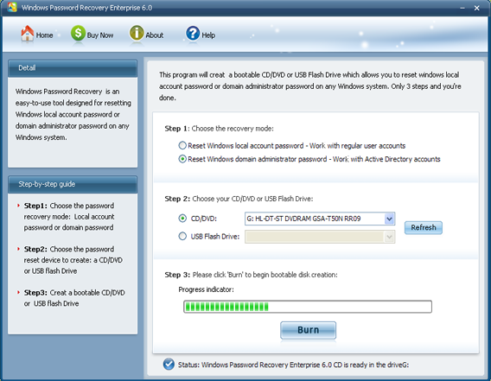
5. The burning successfully completed :
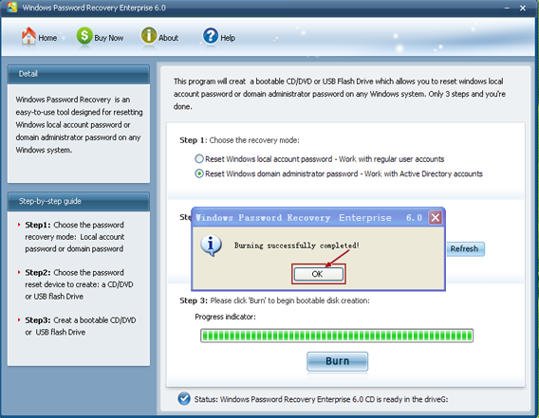

Step 3 . Reset your Windows password:
1. Insert newly created CD/DVD or USB Flash Drive to the computer that you lost its password and reboot it.
NOTE:
To reboot your PC with a CD/DVD disk, it's necessary to change your computer's setting to make it boot from the CD/DVD.
Click here To learn how to set BIOS to boot from the CD/DVD-ROM
To reboot your PC with a USB Flash Drive, It's necessary to change your computer's setting to make it boot from the USB Flash Drive. Click here To learn how to set BIOS to boot from the USB Flash Drive
2. When the CD/DVD boots, you'll see Windows Password Recovery Enterprise 6.0 is initializing (see screenshot below). If so, go on with the next step. If the computer still boots from Windows, it's necessary to change BIOS boot sequence to boot it from CD/DVD.
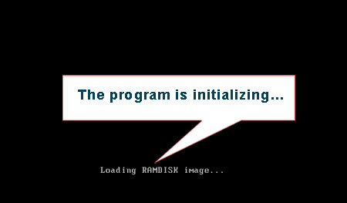
3. Choose the Windows installation to be processed:
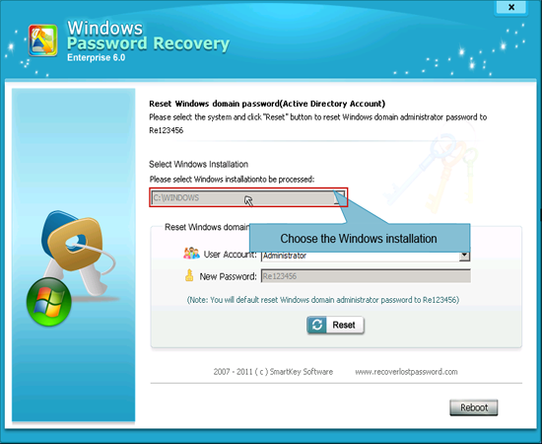
4. Click "Reset" button to reset Windows domain Administrator password to Re123456.
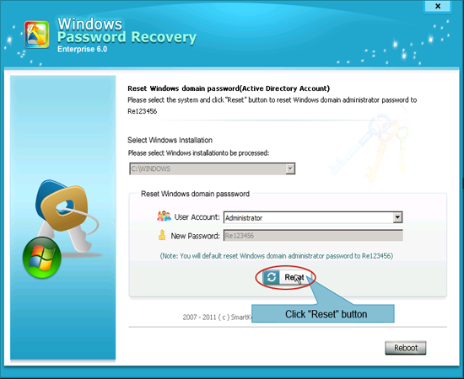
5. Click "OK" button to confirm the operation
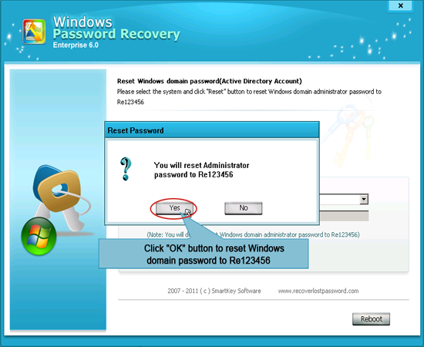
6. You have successfully reset Windows domain password to Re123456.
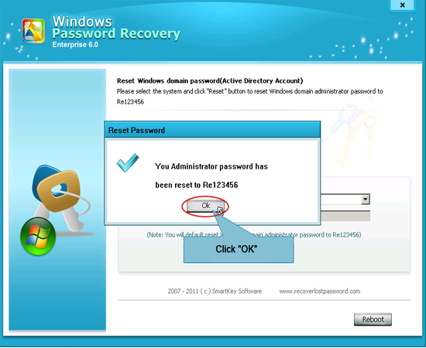
7. Click "Reset" button to reboot your computer.
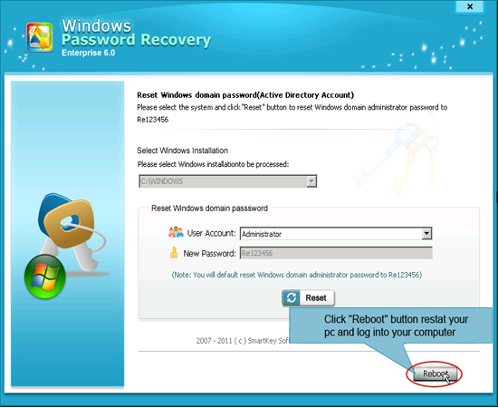
NOTE: To see How-to for the other two versions of Windows Password Recovery 6.0, Please refer to:
How To Use Windows Password Recovery Standard 6.0
How To Use Windows Password Recovery Professional 6.0

Know more about Windows Password Recovery Enterprise Guide from:
http://www.recoverlostpassword.com/products/how_to_use_windowspasswordrecoveryent.html

