How to use Windows Password Recovery Standard?
Windows Password Recovery Standard 6.0 is an easy-to-use tool designed for resetting local administrator passwords on any Windows system. You only need to burn a bootable CD/DVD and boot from CD/DVD to reset your lost password. The following will show you a step-by-step guide to complete windows password reset tasks.

Step 1. Download and Install
1. Download a free demo version of Windows Password Recovery Standard 6.0 (The free demo version lists all the
user names, but doesn't reset the passwords.) .
2. Double-click on the downloaded file to install Windows Password Recovery Standard 6.0. You can install it on any PC you have access to, not necessarily on a computer you wish to unlock.
3. The installation process is quick. Upon successful completion of the installation, an installation successful screen will be displayed! Enable the "Run Windows Password Recovery Standard 6.0. " check-box and click the "Finish" button. Windows Password Recovery Standard 6.0 will be launched automatically.

Step 2 . Burn Windows Password Recovery Standard to CD/DVD:
1. Choose the password recovery mode.
Select "Reset Windows local account password"
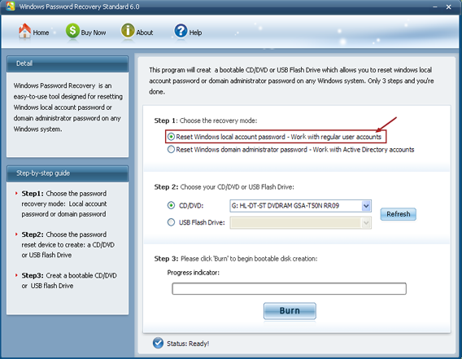
2. Choose what windows password reset device to burn :
Insert a CD/DVD disk into the CD-ROM drive and specify the CD burning drive from the pull-down list of the CD/DVD options.
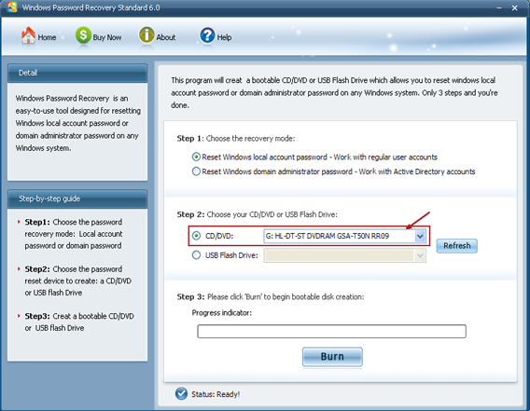
3. Click "Burn" button :
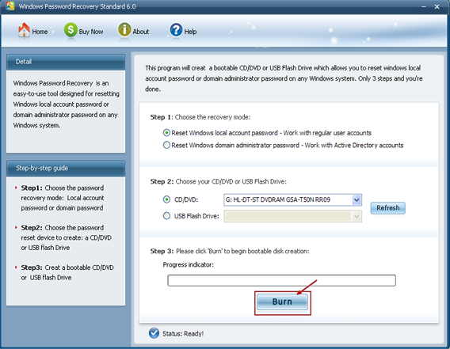
4. The burning process starts :
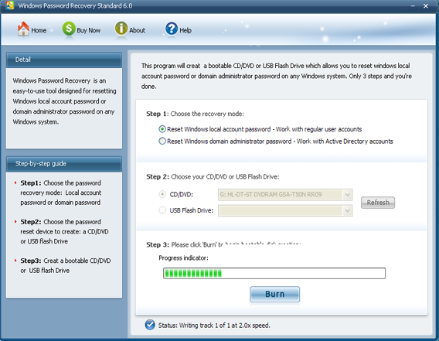
5. The burning successfully completed :
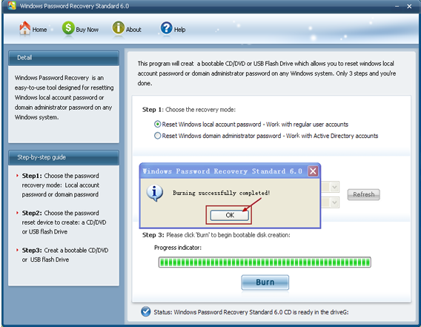

Step 3 . Reset your Windows password:
1. Insert newly created CD/DVD to your computer which you forgot its password and reboot it.
NOTE:
To reboot your PC with a CD/DVD disk, it's necessary to change your computer's setting to make it boot from the CD/DVD.
Click here To learn how to set BIOS to boot from the CD/DVD-ROM
2. When the CD/DVD boots, you'll see Windows Password Recovery Standard 6.0 is initializing (see screenshot below). If so, go on with the next step. If the computer still boots from Windows, it's necessary to change BIOS boot sequence to boot it fromCD/DVD.
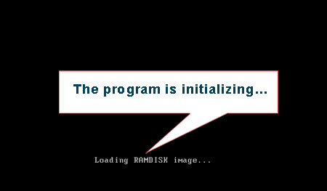
3. Select the user account whose password you want to reset.
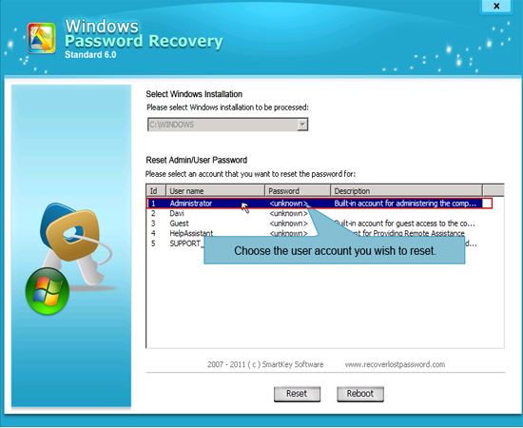
4. Click "Reset" button to process.
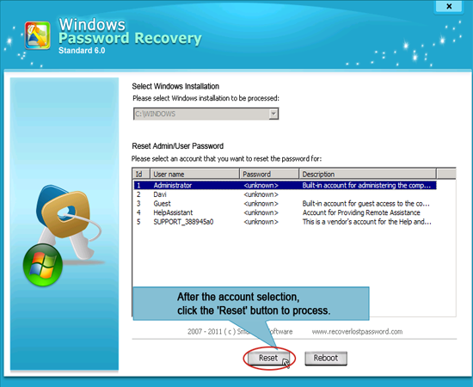
5. Click "Yes" to confirm your action. Or click "No" to undo your selection.
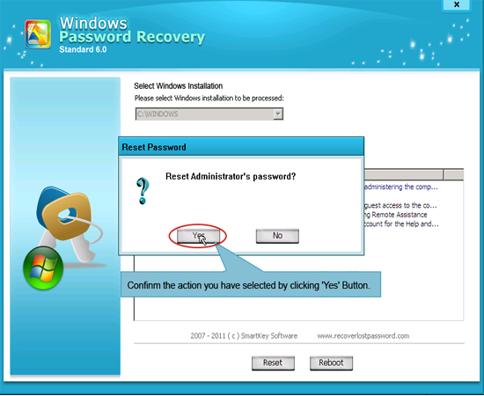
6. In the end, a message box will appear as below, indicating Windows Password Recovery Standard 6.0 has successfully removed the password.
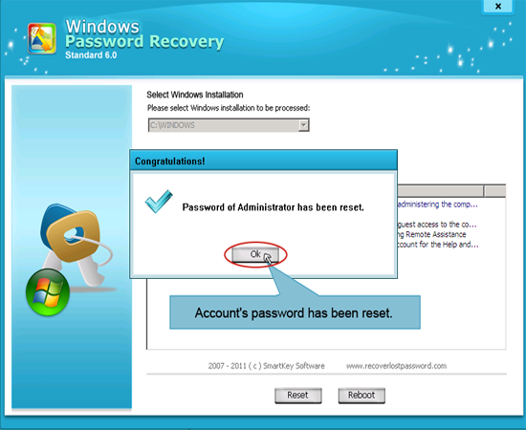
NOTE: To see HowTo for the other two versions of Windows Password Recovery 6.0, Please refer to:
How To Use Windows Password Recovery Professional 6.0
How To Use Windows Password Recovery Enterprise 6.0

Know more about Windows Password Recovery Standard Guide from:
http://www.recoverlostpassword.com/products/how_to_use_windowspr.html

