The most Effective Word Password Tragedies

Microsoft Word documents commonly contain sensitive information including your personal privacy and business data. Therefore, adding passwords for your Word document is getting more and more important. Though it can’t prevent professional hackers to access to your computer, it enables to make sure your data will not be opened or changed by average people. In this article, the author provides some tragedies about Word document passwords, and hope they can help you indeed.

How to create a secure Word password
Below are some tips:
Firstly, you should mind that you can’t use the same password for the different Word documents.
Secondly, you should not use dictionary words. It is easy to be guessed or cracked for others.
Thirdly, you should try your best to create a long and complex password which consists of symbols, numbers, lower and upper caps.
Fourthly, you should change your passwords regularly. Every 4-6 weeks is ideal.

Below is the process on how to create a password:
Step 1: Write down phrase “To be or not to be: that is the question”.
Step 2: Replace “to” with the numeral “2”, and replace “be” with the letter “b”. And then pick the first letter for other words. You phrase now can be “2bon2btitq ”
Step 3: Replace “o” with the numeral “0” and replace “i” with the numeral “1”. So your password appears like “2b0n2bt1tq”
Step 4: Replace some lower case letter with upper case letter, and add some symbol before and after the phrase. Your password has been changed as “@2b0n2BT1TQ#”.

By using this technique, the security of your online accounts and password protected files is high and you will not be able to forget the password.

How to unlock Word password if I forgot it
If you really forgot this password by accident, you can try Word Password Unlocker which is password software to help users to unlock forgotten or lost Word password. It works well with Word 2000, 2003, 2007. Follow the easy directions on how to unlock Word document password:

Step 1: Download, install and launch Word Password unlocker.

Step 2: Load password-encrypted Word document on your computer by clicking “open” and choosing the file.
Step 3: Choose the proper recovery mode. Here we recommend “100% instant document decryption”. Click on “Next”.

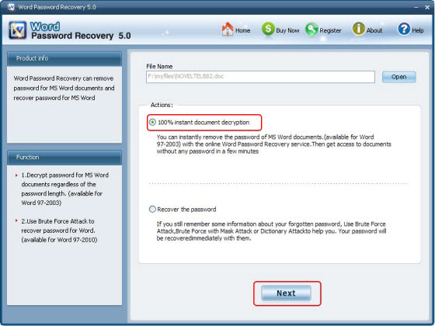

Step 4: Hit “Decrypt Document”. It will take several minutes to finish the recovery.

Step 5: After you are noticed by the indicator “The File Decrypt Successfully”, go to the folder your source file is and the fixed file is what you want.

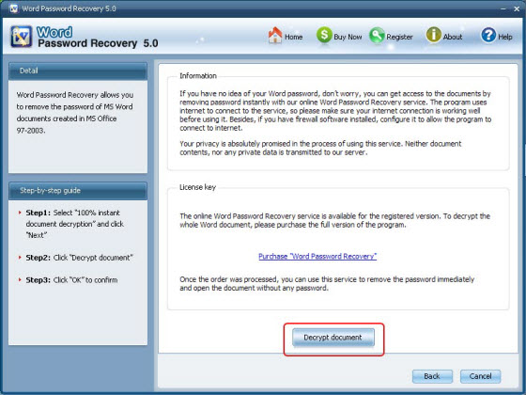

Word password Unlocker is seriously easy for all Word users, even novice. No hesitate, just go to grab it.

•
Article Source:
http://www.recoverlostpassword.com/article/word-password-unlocker.html

