Recover Yahoo Password Unusually but Super Easily and Quickly
Yahoo! is known for across the world with its web portal, search engine, Yahoo! Mail, Yahoo! Answers, Yahoo! Messenger etc. Nowadays, more and more people are using it. Most of them have 2 or 3 or even more Yahoo accounts, one or two for personal, and others either for business or entertainment etc. However, when you have built more than 1 Yahoo accounts, probably you are easy to forget some of your Yahoo accounts information, say usernames, passwords, and security questions. Then you may ask can we recover Yahoo password? Certainly the answer is “Sure”.
In order to remember all our Yahoo passwords easily and mechanically, we always use a web browser instead of writing all them down in paper. Opera at present is the most popular mobile web browser and desktop browser in many countries. With only a click to choosing remembering passwords when you first visit your Yahoo E-mail or Messenger from Opera, your passwords will be remembered forever by Opera. That’s to say, next time you visit it again, you don’t need to enter your Yahoo account usernames as well as passwords. But one day, you got Opera installed on your mobile phone, and for convenience you wanted to let your Yahoo usernames and passwords remembered on your mobile phone. But unluckily, you got no clues about them. Then how would you do? Tell you one more bad news. Opera is not like IE or Firefox, which doesn’t have a built-in function for making it possible to view passwords stored there. At this time, don’t get mad and disappointed. Yahoo password recovery from Opera won’t be that complicated if you use a third application.
Some Opera users my hate Opera because Opera doesn’t implement the function of viewing passwords in the browser, but as a very competitive web browser, Opera stays true to its goal of providing a browser that operates across devices, platforms and operating systems, while delivering a faster, more stable and flexible internet experience that its competitors. Therefore Opera never lacks of popularity. That’s to say, to crack Yahoo password from Opera will always be extremely important for Opera users.
A very good Yahoo password cracker here I would like to introduce to you is Opera Password Recovery 5.0. This is just like Opera Wand which can display your stored Yahoo passwords on Opera as well as other websites accounts and passwords.
As I have said before, Yahoo password recovery is not complicated at all. Following are the steps of how to reset Yahoo password by Opera Password Recovery 5.0, which can prove what I’ve said.
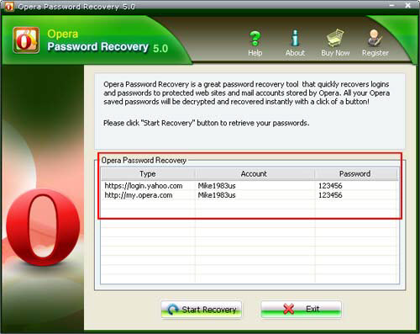
Step1. Free download Opera Password Recovery 5.0 and run it.
Step2. Click “Start Recovery” button, and then a list of emails with sever address, login, passwords will be displayed in the box.
Step3. Find out your Yahoo accounts, and passwords. If you want to change Yahoo passwords, then copy the displayed passwords and login into Yahoo, change the passwords there.
Isn’t it a magic Yahoo password finder? Easy and quick, it’s really impressive. Try it, you won’t be disappointed!
Related Article:
http://www.recoverlostpassword.com/article/yahoo-password-recovery.html

