The Guide on how to recover Password for WinZIP/ZIP archives!
Tips: Here is a concise user guide for you to quickly get familiar with the program. Any inquiries about using the ZIP Password Recovery 5.0, please refer to the "Help" document integrated in the program.
Step 1: Click "Open" to open the target Zip file with the program.
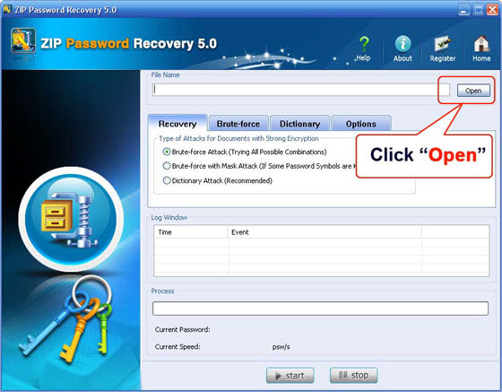
Select your file in the Open File window and click "Open".
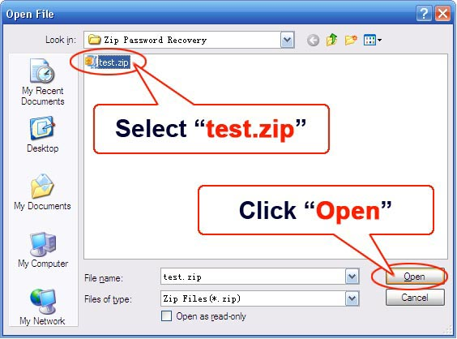
Step 2: On the "Recovery" tab, select "Brute-force Attack (Trying All Possible Combinations)".
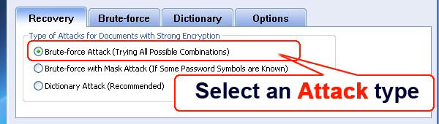
Step 3: Click "Start" button in the Menu to initiate the program.
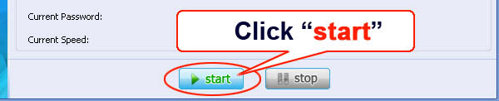
Step 4: The program is processing for the password. Sometime later, a message box pops up to you, displaying the expected password. Click "OK".
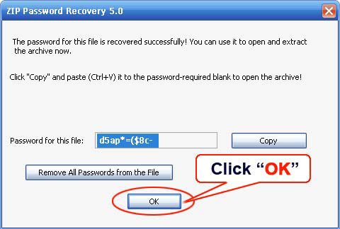

Know more about ZIP Password Recovery Guide from:
http://www.recoverlostpassword.com/products/how_to_use_zippr.html

